Tableau Challenge

1. **Pre-work**: We will be using the [FoodEnvironmentAtlas2014 datasource](https://osu.instructure.com/courses/92002/files/28162572/download?wrap=1) that is on Carmen. Download it and get familiar with the Variable_List worksheet. It gives you all the information you need about picking the right variables for the exercises. Connect to it from Tableau.

Done

1. **Charting obesity:** Create histograms of the adult obesity rate by county for both 2010 and 2012 (two histograms). What is different about these two histograms? Why do you think that is?

Here is the histogram visualization.

The difference between the two histograms:

The both histograms look very different, as the data collection in 2010 and 2012 are more different.

Here in 2010 histogram, the state Montana and Texas are green colored, it shows multiple times and the data is showing county wise.

But in 2012 histogram, Montana and Texas are just showing only once and big bar. As the data collection is good in 2012 so the histogram looks clearer and the data is showing state wise.

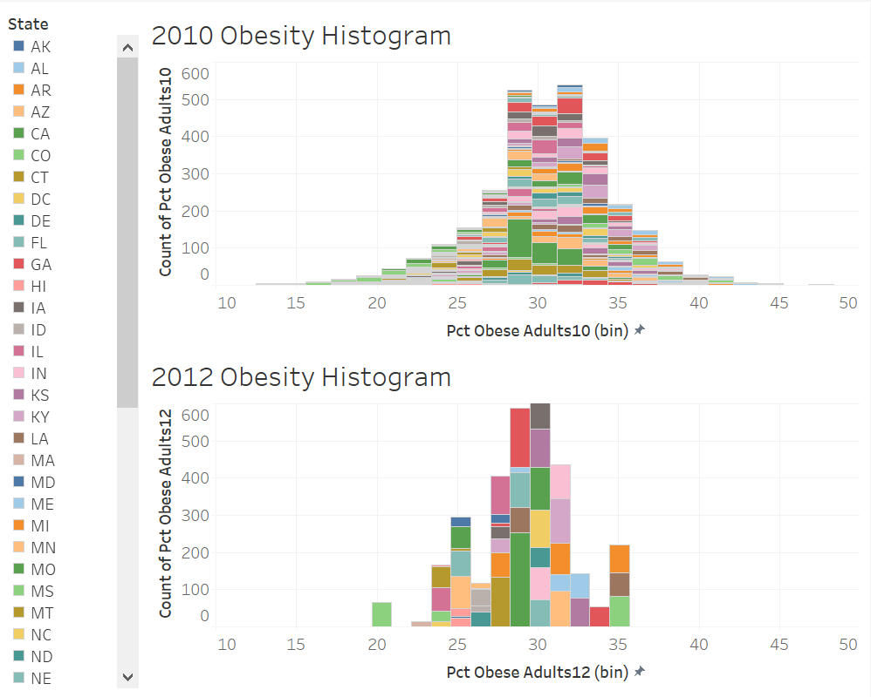

1. **Mapping obesity :** Create two US maps that each show, with differences in color, each county’s adult obesity rate for 2010 and 2012 (two maps). For clarity, filter out Alaska and Hawaii. Use 7-step differences between red and green to show the lowest (green) rates to the highest (red) rates. What is the most striking difference between the two maps? Why do you think this is? *HINT: don’t use Excel or anything fancy to massage the data – just use Tableau!*

For clarity, Alaska and Hawaii are filtered out. 7-step differences between red and green to show the lowest (green) rates to the highest (red) rates used.

For 2010 map shows the county wise data and the 2012 map shows state wise data.

For some states in 2012 map, it shows almost red in Cental and East side states. This is almost similar to the county wise data in 2010. Lot of states are showing grey looks like much data has not changed.

But some data are missing, in 2010 map, some counties of South Dakota and Arizona has deep red, but in 2012 map it is not showing as red.

So, we may miss some data while visualization state wise. Need to mention that to the customer/observer.

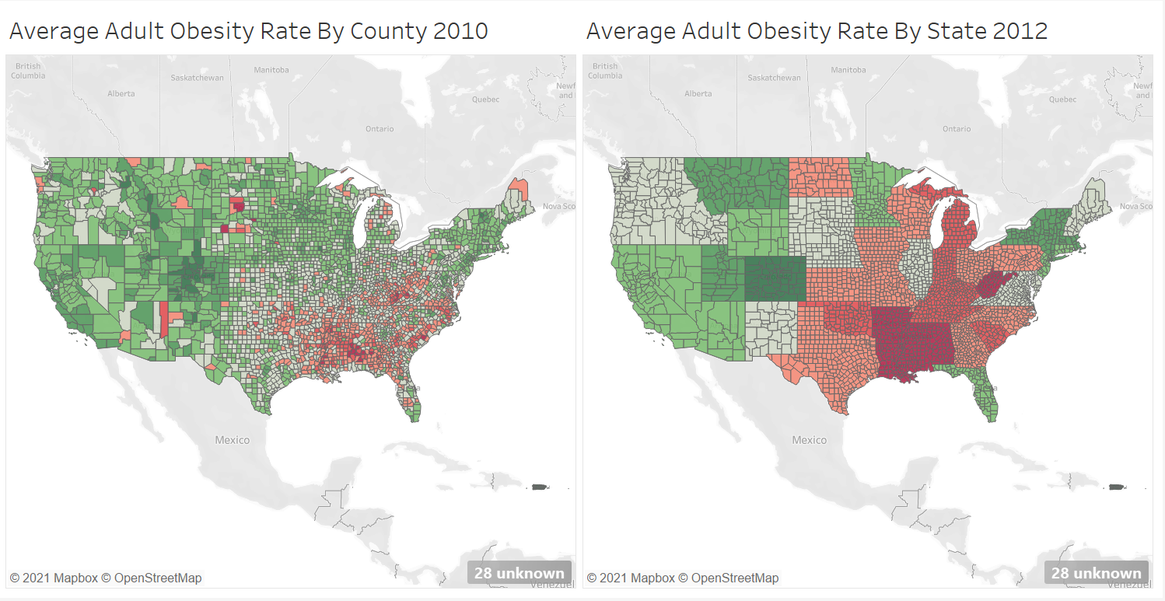

1. **Dashboarding obesity :** Create a dashboard of these four visualizations. Place the four visualization to optimize the ability to make comparisons between them.

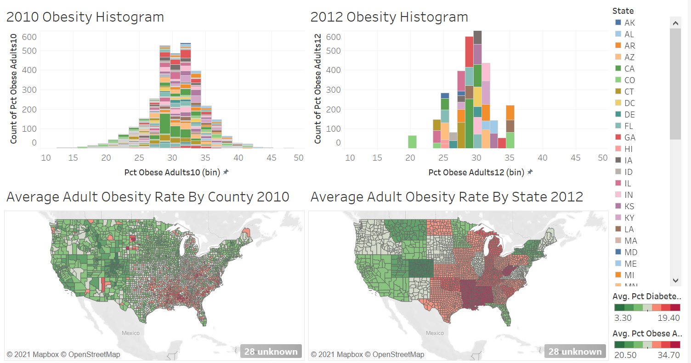

1. **Mapping differences**: Create a calculated field that compares a county’s adult obesity rate in 2010 to its rate in 2012. The field will have one of three values: “Better” if the rate went down, “Same” if it stayed the same, and “Worse” if it got worse.

Calculated field ‘Comparison’ is created with the below logic

IF ([Pct Obese Adults10] - [Pct Obese Adults12]) > 0) THEN "Better"

ELSEIF (([Pct Obese Adults10] - [Pct Obese Adults12]) = 0) THEN "Same"

ELSE "Worse"

END

Create a second calculated field that displays the actual difference between the 2010 and 2012 rates. Create two duplicates of either of your maps from #3 and change the coloring to of those maps, by county, to the two fields you’ve just created (i.e., 2 new maps). Use a traffic light color scheme for the categorical field. Use a seven-step color scheme (the same as in #3) for the continuous field. Make sure on the continuous field map that the center (i.e., neutral color) is on zero!

Created field named “Numeric Difference Per County” with the below logic:

[Pct Obese Adults12] - [Pct Obese Adults10]

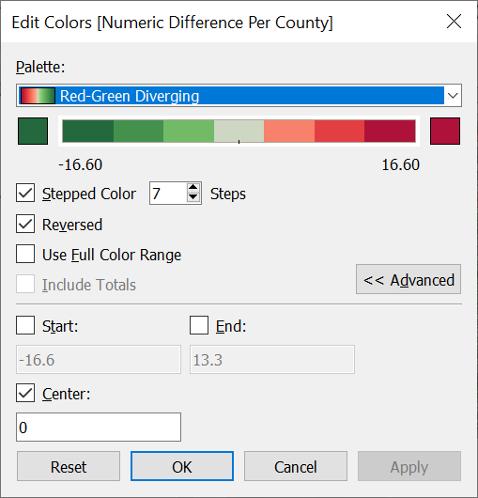

1. **Dashboard Part 2**: Put both maps on a second dashboard. Which calculated field do you think better communicates which counties got better and worse, and why do you think that?

Here the two maps are showing the data county wise. The 1st map shows categorical data and this do not give really a clear picture of difference (same is very less). The

2nd map shows the continuous data and this shows that the obesity rate has not changed that much in last 2 years. So, I think continuous calculation goes more better for the map visualization.

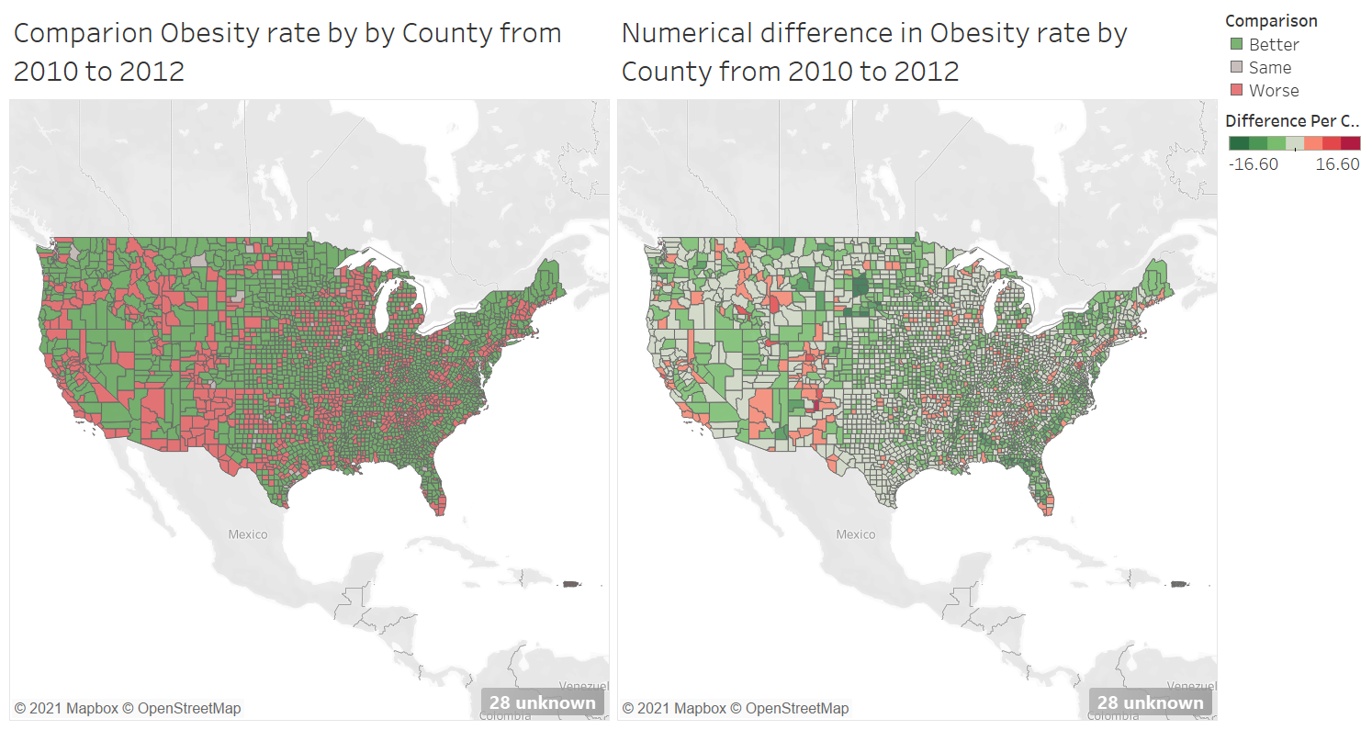

1. **Connecting to Diabetes** : Who cares about obesity? What we really care about diabetes. Create a scatter plot of each county’s 2010 adult obesity rate vs. adult diabetes rate. Visually, does there seem to be a correlation? Create a trend line – what do the trend line attributes tell you about the fit of this line? Is there a correlation? Why do you think that way?

Young generations and some conscious parents are really caring about obesity. Otherwise, obesity leads to many diseases.

For Diabetes, we need to maintain the average weight, eating healthy food, and being active. Taking medicine as needed, and most important is self-management.

In the scatter plot, it shows the obesity is 50% and the diabetes is 20%. This trend line shows the linear relation. As almost obesity is more tends to diabetes.

